2.3.1 Limit Laws

We begin this section by stating some intuitively obvious limit laws. We will be able to provide rigorous poofs of these laws at the end of section 2.5.

Theorem: Suppose that c is a constant, n is a positive integer and the limits and exist. Then,
- provided
- provided is positive when n is even

Example 1:
Use the limit laws to calculate the following limit.

We calculate that:

We calculate that:

Note: You will not be required to provide the limit law numbers on exams/homeworks, but you should know how to apply the laws.

We see in the examples above that the final limits could be obtained by simply plugging the number x is approaching into the expression. The following theorem makes this idea precise.

Theorem (Direct Substitution Property): If is a polynomial or a rational function (i.e. the ratio of two polynomial functions) and a is in the domain of , then .

Note: Using the above theorem, we see that we could have done part (a) of the most recent example as follows: .

Example 2: Evaluate .

We see that we cannot use a direct substitution here because we obtain a division by 0. However, this does not mean that the limit DNE. We must continue to investigate this limit and begin doing so by algebraically simplifying the expression:
.
Now, we crucially note that since h is approaching 0, h never actually gets to 0. Thus, we are justified in cancelling the h and then applying the direct substitution property:
.

Note: The expression will not always simplify nicely when the direct substitution property cannot be initially applied. The next example illustrates this.

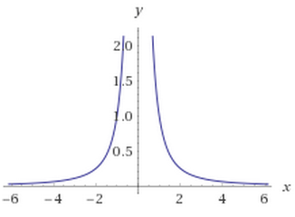
Example 3: Evaluate

First, note that the direct substitution property cannot be applied initially. Since the expression is of the form 1 divided by something getting close to 0, we take an intuitive approach. Specifically, note that and . So, we conclude that .

Strategy for evaluating a limit of the form :
- We first try to plug the value of a in for x. If we get a real number, then that number is our answer. If we get an undefined expression, we proceed to step 2.
- If the limit of both the numerator and denominator is 0, then it is helpful to algebraically simplify before calculating a limit. Otherwise, we proceed to step 3.
- If the limit of the denominator is 0 and the limit of numerator is not, then we check to see if/how the limit approaches infinity.

Note: Technically we should have specified in the above strategy that f and g are polynomials. However, we will see later on the strategy may be applied for essentially any functions we will encounter in Calculus one.

Note: This strategy is not perfect! Step 2 is especially not perfect, as sometimes algebraic simplifications will not yield an answer. Later on, we will develop more sophisticated techniques for dealing with the situation where both numerator and denominator approach 0.

Example 4: Evaluate

We calculate:

Example 5: Explain why does not exist.
We notice that the is undefined. So we see that a direct substitution does not work. To confirm that the limit does not exist we will check the limit from both sides. We see that:
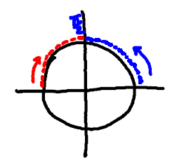

Since the limits from the left and the right do not agree we therefore conclude that does not exist.

We now recall an important definition from Precalculus.
Definition: The absolute value of a real number x is: .

Example 6: Prove that does not exist.
Using the above definition, we note that .
Also, we note that .
Since the left and right hand limits are different, it follows that the limit does not exist.

Example 7: Calculate the following limit:

We see that if we attempt a direct substitution we arrive at the value , which is undefined. We should attempt to simplify the expression to investigate further.
Since we still cannot compute the limit using a direct substitution we will check to see if the limit does not exist by looking at the limit from both sides.

Since the limits from the left and the right do not agree we therefore conclude that does not exist.

Example 8:
Suppose that f has the following piecewise definition:

Compute the following limits

We can check this limit directly since is not a potential break point of the graph.

We should check the limit from both sides, since a potential break occurs at.
Therefore, since the limits from the left and the right agree we know that .

We should check the limit from both sides, since a potential break occurs at.
Since the left and right hand limits are different, it follows that the limit does not exist.
Obtaining Limits by Squeezing

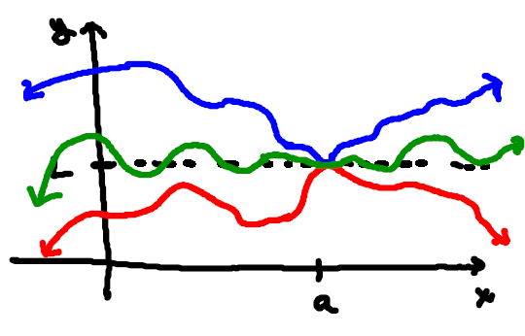
General Idea:
Suppose we have three functions where for all values of x near some value a.

If it is the case that

then, it would appear that there is no other choice than for

The Squeeze Theorem: If when x is near a (except possibly at a) and
then,

Example 9: Show that

We know that from our knowledge of trigonometry that for any:
$f\left(x\right)$ $g\left(x\right)$ $h\left(x\right)$

If we multiply by we obtain:

We see that we have bounded our original function and we know that and . Therefore, by the Squeeze Theorem, we know that .

Example 10: Find (with justification) .
We know that from our knowledge of trigonometry that for any :
If we make all sides a power of e and then multiply by we obtain:

We see that we have bounded our original function and we know that and . Therefore, by the Squeeze Theorem, we know that .

